**Assignment -2**

|  |  |
| --- | --- |
| Assignment Date | 21 September 2022 |
| Student Name | V.A.Jinto Maria |
| Student Roll Number | 820419205026 |
| Maximum Marks | 2 Marks |

1.Create User tables with user with email, username, roll number ,password in IBM db2

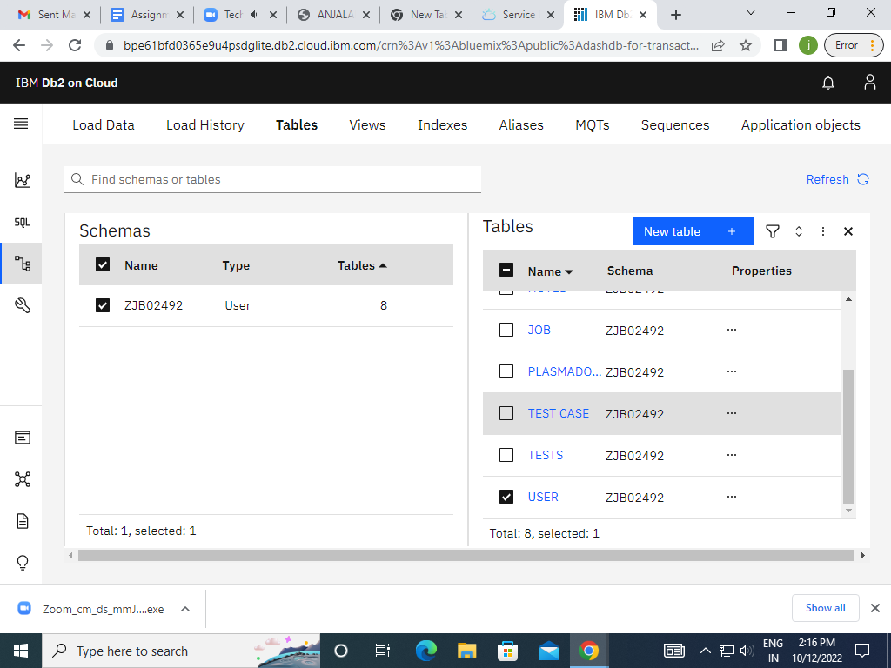

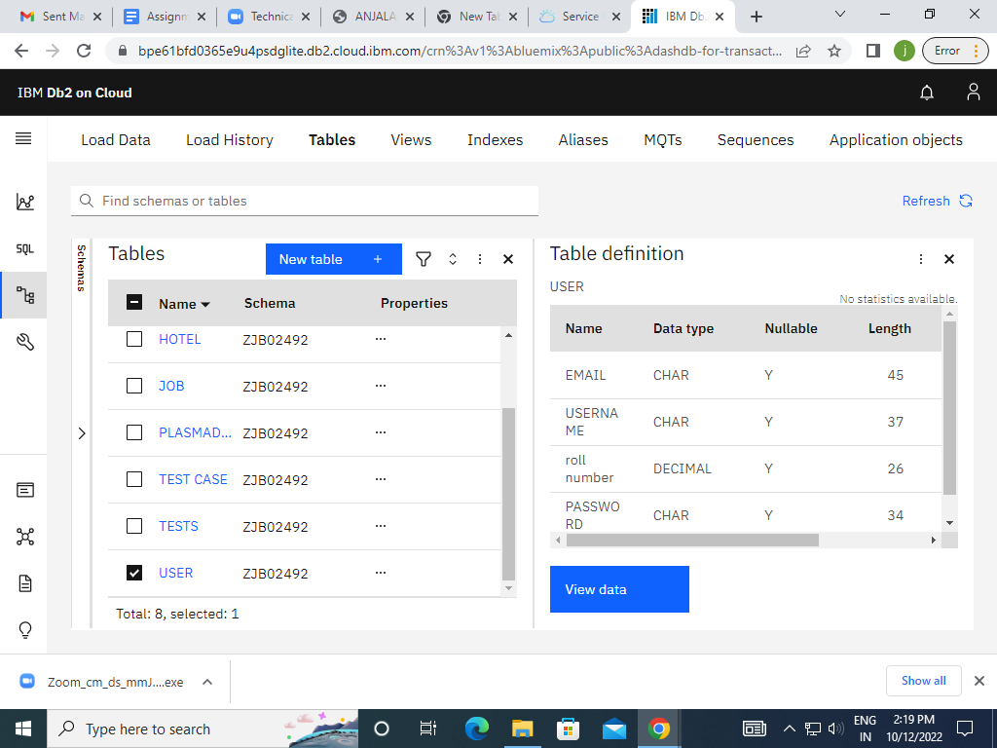

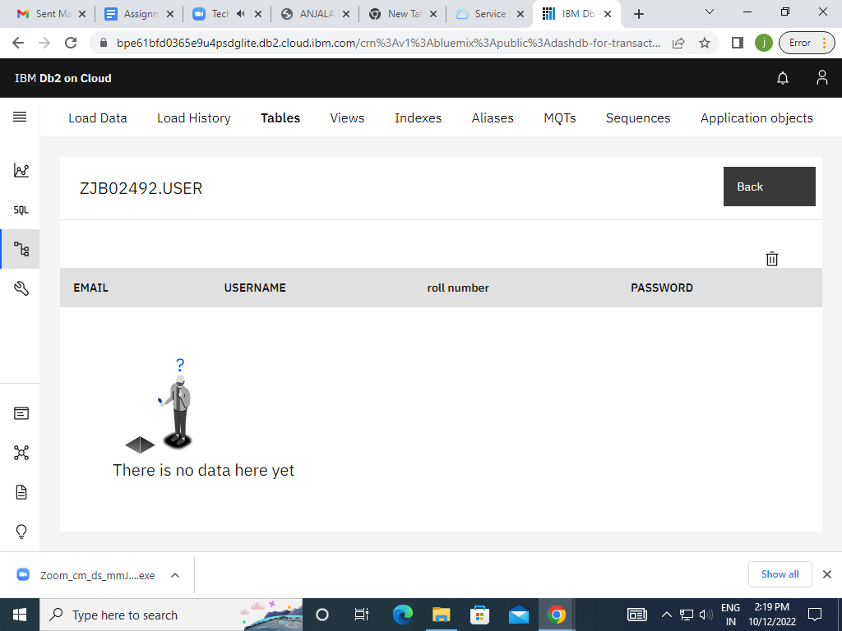

2.Perform UPDATE, DELETE queries with job tables.

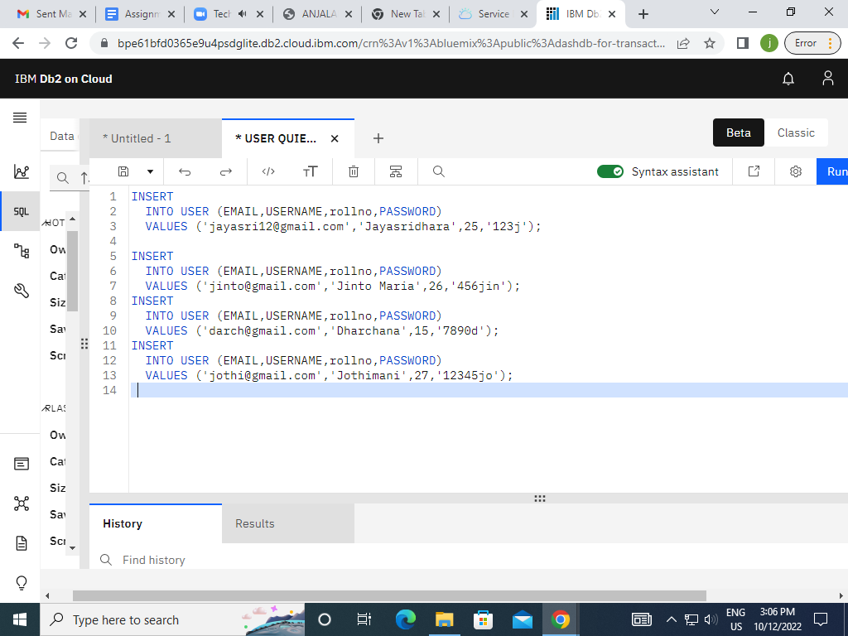

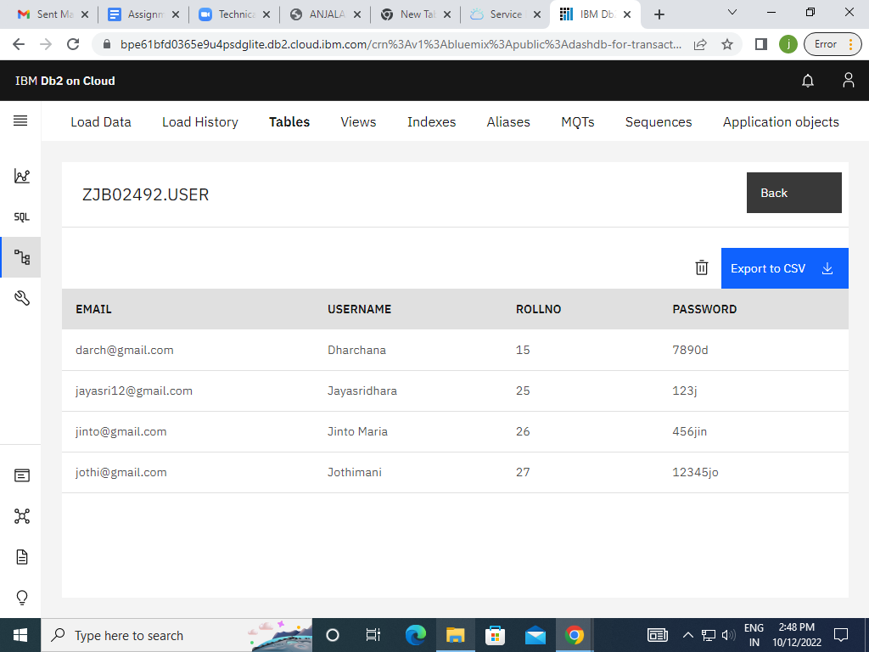

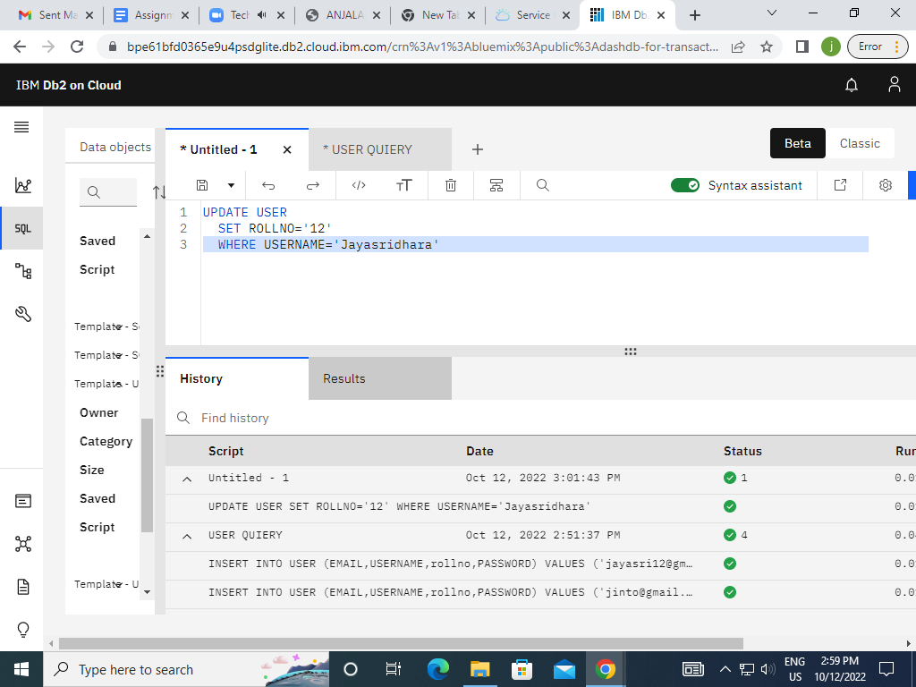

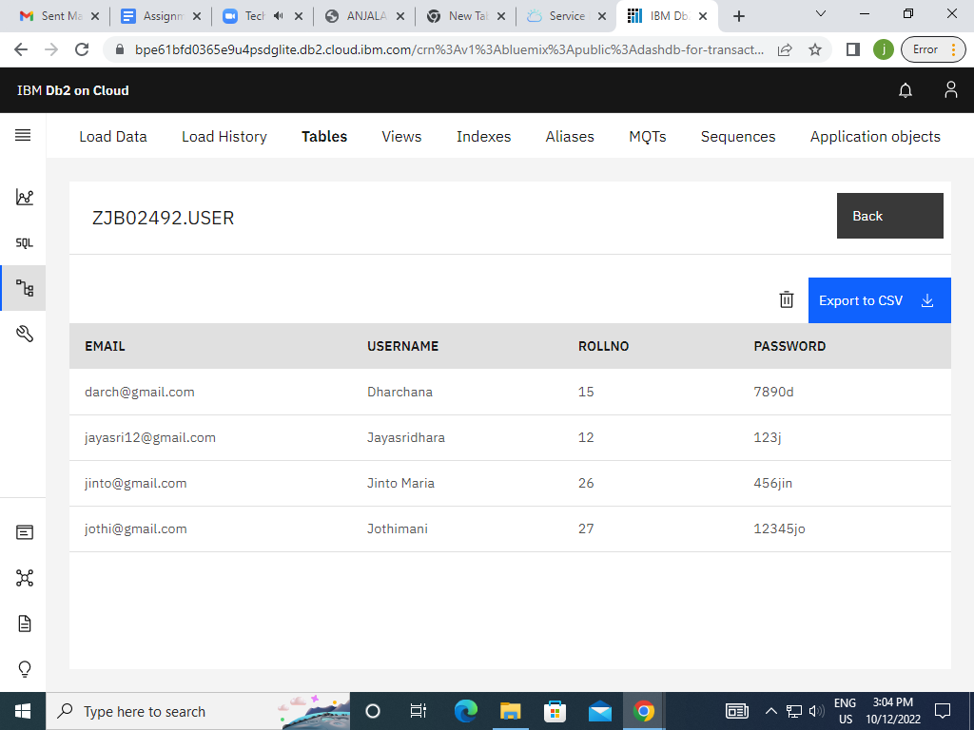

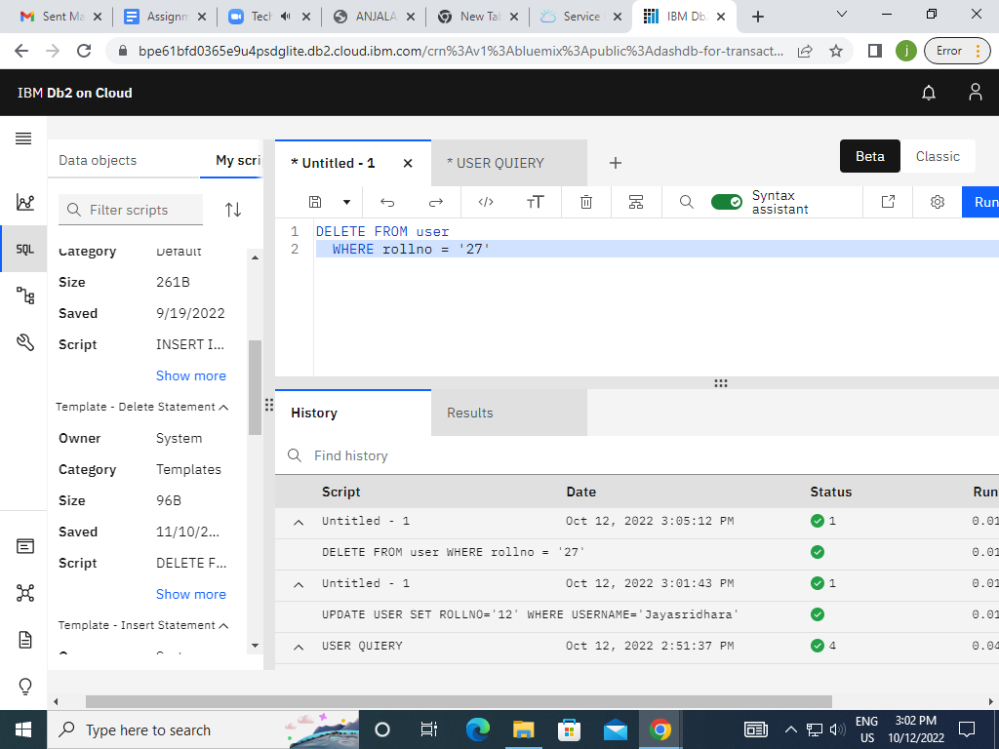

3.Connect python to db2.

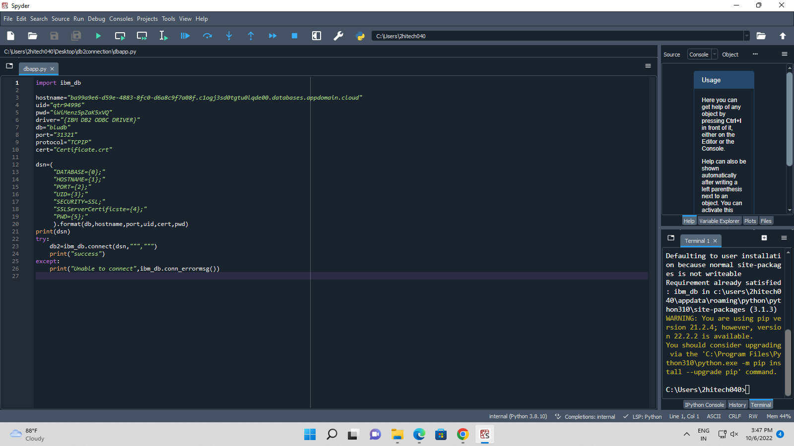

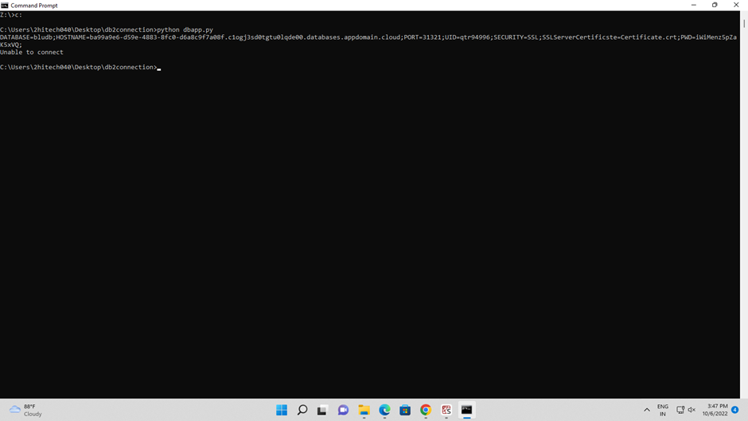

4.Create a flack app with registration page, login page and welcome page.By default load the registration page once the user enters all the fields store the data in database and navigate to Login page authenticate user username and password. If the user is valid show the welcomed page

**Source code:**

from flask import Flask, render_template, request, redirect, url_for, session

import ibm_db

import re

app = Flask(__name__)

app.secret_key = 'a'

conn = ibm_db.connect("DATABASE=bludb;HOSTNAME=b70af05b-76e4-4bca-a1f5-23dbb4c6a74e.c1ogj3sd0tgtu0lqde00.databases.appdomain.cloud;PORT=32716;SECURITY=SSL;SSLServerCetificate=DigiCertGlobalRootCA.crt;UID=jsd43112;PWD=tjhB5aldnGUWMIa0", '', '')

@app.route('/')

def home():

return render_template('home.html')

@app.route('/login', methods=['GET', 'POST'])

def login():

global userid

msg = ''

if request.method == 'POST':

username = request.form['username']

password = request.form['password']

sql = "SELECT * FROM users WHERE username =? AND password=?"

stmt = ibm_db.prepare(conn, sql)

ibm_db.bind_param(stmt, 1, username)

ibm_db.bind_param(stmt, 2, password)

ibm_db.execute(stmt)

account = ibm_db.fetch_assoc(stmt)

print(account)

if account:

session['loggedin'] = True

session['id'] = account['USERNAME']

userid = account['USERNAME']

session['username'] = account['USERNAME']

msg = 'logged in successfully!'

return render_template('dashboard.html', msg=msg)

else:

msg='Incorrect username / password!'

return render_template('login.html',msg=msg)

@app.route('/register', methods=['GET', 'POST'])

def register():

msg = ' '

if request.method == 'POST':

username = request.form['username']

email = request.form['email']

password = request.form['password']

sql = "SELECT * FROM users WHEREusername = ?"

stmt = ibm_db.prepare(conn, sql)

ibm_db.bind_param(stmt, 1, username)

ibm_db.execute(stmt)

account = ibm_db.fetch_assoc(stmt)

print(account)

if account:

msg = 'Account already exit!'

elif not re.match(r'[^@]+@[^@]+\.[^@]+', Email):

msg = 'invalid email address!'

elif not re.match(r'[A-Za-z0-9]+', username):

msg = 'Name must contain only characters and numbers!'

else:

insert_sql = "INSERT INTO JOB VALUES (?,?,?)"

prep_stmt - ibm_db.prepare(conn, insert_sql)

ibm_db.bind_param(prep_stmt, 1, username)

ibm_db.bind_param(prep_stmt, 2, email)

ibm_db.bind_param(prep_stmt, 3, password)

ibm_db.execute(prep_stmt)

msg = ' you have successfully registered !'

elif request.method == 'POST':

msg = 'Please fill out the form!'

return render_template('register.html',msg = msg)

@app.route('/dashboard')

def dash():

return render_template('dashboard.html')

@app.route('/apply', methods=['GET', 'POST'])

def apply():

msg = ''

if request.method == 'POST':

username = request.form['username']

email = request.form['email']

qualification =request.form['qualification']

skills = request.form['skills']

jobs = request.form['s']

sql = 'SELECT * FROM users WHERE username= ?'

insert_sql = "INSERT INTO jOB VALUES (?,?,?,?,?)"

prep_stmt = ibm_db.prepare(conn, insert_sql)

ibm_db.bind_param(prep_stmt, 1, username)

ibm_db.bind_param(prep_stmt, 2, email)

ibm_db.bind_param(prep_stmt, 3, qualification)

ibm_db.bind_param(prep_stmt, 4, skills)

ibm_db.bind_param(prep_stmt, 5, jobs)

ibm_db.execute(prep_stmt)

msg = 'you have successfully applied for job !'

session['loggedin'] = True

elif request.method == 'POST':

msg ='please fill out the form!'

return render_template('apply.html',msg = msg)

@app.route('/display')

def display():

print(session["username"],session['id'])

cursor = mysql.connection.cursor()

cursor.execute('SELECT * FROM job WHERE userid=%s', (session['id']))

account = cursor.fetchone()

print("accountdisplay", account)

return render_template('discplay.html', account = account)

@app.route('/logout')

def logout():

session.pop('loggedin', None)

session.pop('id', None)

session.pop('username', None)

return render_template('home.html')

if__name__ == '__main__'

app.run(host='0.0.0.0')

